

Tribhuvan University
Faculty of Humanities and Social Sciences

Project Report
on
Online Examination System(ExamPro)

In partial fulfillment of the requirements for the Bachelors in Computer Application

Submitted to
Department of Computer Application
Everest Innovative College
Solteemode, Kathmandu

Submitted by
ROHAN MAHARJAN
8th Semester, 2020 Batch
Reg. no: 6-2-713-20-2020

Under the Supervision of
Bhesh Chaudhary


Tribhuvan University
Faculty of Humanities and Social Sciences

Everest Innovative College
Solteemode, Kathmandu
Bachelor in Computer Applications (BCA)

SUPERVISOR’S RECOMMENDATION

I hereby recommend that this project prepared under my supervision by Rohan Maharjan entitled “Online Examination system” in the Partial Fulfillment of requirement for the degree of Bachelor in Computer Application is recommended for that final evaluation.

Bhesh Chaudhary
Project Supervisor
BCA Department
Everest Innovative College



Tribhuvan University
Faculty of Humanities and Social Sciences
Everest Innovative College
Solteemode, Kathmandu
Bachelor in Computer Applications (BCA)

LETTER OF APPROVAL

This certify that this project is prepared by Rohan Maharjan entitled “Online Examination system” in the Partial Fulfillment of requirement for the degree of Bachelor in Computer Application has been evaluated. In our opinion it is satisfactory in the scope and quality as a project for the required degree.

Kishor Kafle
Program Coordinator
Everest Innovative College

Bhesh Chaudhary
Supervisor, BCA Department
Everest Innovative College

Internal Examiner

External Examiner

ABSTRACT
The Online Examination System is a web-based solution designed to automate and simplify the process of conducting examinations in educational institutions. The system enables students to securely register, log in, access exams, and submit answers in a structured and time-bound environment. At the same time, administrators can manage question banks, create and schedule exams, monitor student performance, and generate result reports efficiently. This system reduces manual effort, minimizes errors, and ensures transparency in the examination process.

Additionally, the Online Examination System enhances user experience by integrating intelligent features such as automated evaluation and performance-based analytics. These features help identify learning patterns and provide personalized feedback to students, thereby improving overall academic outcomes. With built-in security measures and real-time monitoring, the system promotes fairness and reliability in online assessments. Overall, the Online Examination System serves as an effective tool for improving efficiency, accessibility, and accuracy in modern examination management.

Keywords: Online Examination System, Online Assessment, Automated Evaluation, Student Performance, Examination Management.

ACKNOWLEDGEMENT
I would like to express our foremost gratitude to our supervisor Mr. Bhesh Chaudhary who gave us the golden opportunity to do this wonderful project on the topic of Online Examination system, and for his constant, valuable and timely guidance, co-operation, encouragement and monitoring during the development of this project.
We would also like to express our special thanks of gratitude to our Campus Chief Mr. Deepak Kumar Jha who gave us permission for doing this Project.
We would also like to express our special gratitude and thanks to our BCA Program Coordinator Mr. Kishor Kafle for his guidance, assistance and monitoring for the completion of this Project.
We are highly indebted to Everest Innovative College for their guidance and constant supervision as well as for providing necessary information regarding the Project and support in the completion.
We would also like to thank our parents and friends who helped us directly and indirectly to finalizing this project within the limited time frame.
In the end, we would also like to thank Tribhuvan University for giving us this opportunity to learn project ethics at this early level, as well as for helping us assess and broaden our knowledge.

Yours sincerely,
Rohan Maharjan

TABLE OF CONTENTS
ABSTRACT i
ACKNOWLEDGEMENT ii
LIST OF FIGURES v
LIST OF TABLES vi
LIST OF ABBREVIATION/ACRONYM vii
CHAPTER 1 INTRODUCTION 1
1.1 Introduction 1
1.2 Problem Statement 1
1.3 Objective 2
1.4 Scope and Limitation 2
1.5 Development Methodology 3
1.6 Report Organization 5
CHAPTER 2 BACKGROUND STUDY AND LITERATURE REVIEW 6
2.1 Background Study 6
2.2 Literature Review 6
CHAPTER 3 SYSTEM ANALYSIS AND DESIGN 9
3.1 System Analysis 9
3.2 System Design 22
3.3 Algorithm for Online Examination System: 26
CHAPTER 4 IMPLEMENTATION AND TESTING 29
4.1. Implementation 29
4.2. Testing 31
4.3 Result Analysis 37
1. Coordinate Acquisition 39
CHAPTER 5 CONCLUSION AND FUTURE RECOMMENDATIONS 41
5.1 Lesson Learnt / Outcome 41
5.2 Conclusion 42
5.3 Future Recommendations 42
REFERENCES 44
APPENDIX: SYSTEM SCREENSHOTS 45

LIST OF FIGURES
Figure 1.1: RAD Methodology of Online Examination system 4
Figure 3.1: Use Case diagram of Online Examination system……………………..…….10
Figure 3.2: Gantt Chart for Online Examination system 12
Figure 3.3: Class Diagram for Online Examination system 13
Figure 3.4: Object Diagram of Online Examination system 14
Figure 3.5: Sequence diagram for Online Examination system 15
Figure 3.6: Admin Activity Diagram for Online Examination system 17
Figure 3.7: User Activity Diagram for Online Examination system 19
Figure 3.8: Refinement of Class Diagram for Online Examination system 20
Figure 3.9: Component Diagram for Online Examination system 21
Figure 3.10: Deployment Diagram for Online Examination system 22

LIST OF TABLES
Table 3.1: Gantt table for Online Examination system 12
Table 4.1: Tools Used for Online Examination system……………………………….......29
Table 4.2: Registration test case for Online Examination system 31
Table 4.3: Login test case for Online Examination system 33
Table 4.4: Admin login test case for Online Examination system 33
Table 4.5: Adding books test case for Online Examination system 34
Table 4.6: Update book test case for Online Examination system 34
Table 4.7: Searching book test case for Online Examination system 35
Table 4.8: Forgot password test case for Online Examination system 35
Table 4.9: System testing for Online Examination system 36

LIST OF ABBREVIATION/ACRONYM

Abbreviation/Acronym | Description
API | Application Programming Interface
BCA | Bachelors in Computer Application
DB | Database
IDE | Integrated Development Environment
JS | Javascript
SQL | Structured Query Language
UI | User Interface
VS | Visual Studio

CHAPTER 1
INTRODUCTION

1.1 Introduction
The Online Examination system is a modern software solution designed to transform library operations, making them more user-friendly and efficient. The Online Examination System (OES) is a web-based platform designed to automate the process of conducting exams, assessing student performance, and generating results in real time. The system replaces the traditional pen-and-paper method of conducting examinations with an interactive, secure, and scalable digital solution. It provides functionalities for creating question banks, scheduling exams, monitoring students, evaluating responses, and generating reports automatically. The system supports various types of questions such as multiple-choice, true/false, and short-answer types.
In this system, administrators can manage users and exams, teachers can design questions and analyze student results, and students can register, log in, take exams, and instantly view their scores. The automation of grading for objective questions significantly reduces the workload of educators and ensures fairness and transparency in evaluation. By leveraging web technologies such as HTML, CSS, JavaScript, PHP, and MySQL, this system ensures data integrity, security, and user convenience. It can be deployed locally or on a web server, allowing institutions to conduct examinations for a wide range of students simultaneously.
The Online Examination System aims to provide a reliable, user-friendly, and cost-effective examination platform that can serve as an alternative to manual exam processes in schools, colleges, training institutes, and certification centers.ore accessible, organized, and engaging environment for both users and administrators.

1.2 Problem Statement
The traditional examination process has several inherent limitations that hinder its efficiency and accuracy. Manual paper-based exams require extensive administrative work, including paper printing, question paper distribution, answer sheet evaluation, and result publication. These tasks are time-consuming and susceptible to human error.

In addition, conducting exams for a large number of students requires substantial human and material resources. Storing and managing physical records of exams and results also pose challenges related to data security and accessibility.
Students often face delays in receiving their results due to the manual evaluation process. Furthermore, with the rise of remote education and online learning, there is a growing need for a digital platform that allows students to take exams from any location securely.
Hence, there is a strong need for a computerized examination system that automates question management, exam scheduling, evaluation, and result generation. The proposed Online Examination System aims to address these challenges by offering an integrated solution that improves accuracy, reduces cost, and saves time for both students and administrators.

1.3 Objective
The main objective of this project is to provide best features as mentioned below:
    - To develop a secure, efficient, and user-friendly Online Examination System that automates the entire examination.

1.4 Scope and Limitation
OES (Online Examination System) is a web-based application designed to provide a comprehensive and user-friendly platform for students to register, access, and attempt online examinations at their convenience, as well as for administrators to efficiently manage exam creation, question banks, scheduling, and results processing. This system replaces traditional, manual examination processes, saving time, reducing administrative effort, and enhancing the overall experience for both students and academic staff..
1.4.1 Scope
Enhancing operational efficiency, user satisfaction, and accessibility to digital examination resources is the primary goal of this initiative. Educational institutions and training organizations can utilize the system. Every registered user with a profile in the application can securely access the system to view available examinations, attempt tests, and monitor their performance, while administrators can manage question banks, exam schedules, and monitor user activities.
      - Users can access a user-friendly interface to view available exams, attempt tests, and track their results in real time..
      - The system facilitates efficient administrative management, allowing administrator to create and mange exam and maintain questions .
      - Users will receive performance-based feedback and personalized recommendations for practice tests using intelligent evaluation algorithms.
      - The system incorporates time-bound examinations and automated submission to ensure discipline, fairness, and integrity in the assessment process.
1.4.2 Limitations
While the Online Examination System is designed to enhance user experience and improve assessment efficiency, its performance is highly dependent on stable internet connectivity. Users with poor or no internet access may face difficulties in accessing examinations, submitting answers, or receiving real-time updates during ongoing tests.

Additionally, the system has functional limitations in administrative monitoring. Administrators may not be able to view detailed real-time user activity such as live exam progress or instantaneous behavioral tracking during an examination session. Furthermore, delays in result generation may occur under heavy system load, making it challenging to access slow or delayed result processing immediately.

1.5 Development Methodology
The Agile methodology emphasizes iterative and incremental development, making it ideal for dynamic and user-focused projects. Agile is a flexible, adaptive process that delivers small, functional modules in short cycles, ensuring continuous improvement. With active user collaboration at every stage, Agile allows teams to respond quickly to changing requirements, making the development process more efficient and aligned with user needs.

Figure 1.1: Agile Methodology of Online Examination system
Requirements Planning:
In this phase, the project goals and scope were defined with input from teachers and academic staff. Discussions focused on user needs such as an easy-to-use interface for accessing exams, answering questions, time management, and result viewing.
User Design (Prototyping):
Prototypes were created to show key features like exam dashboards, question displays, timers, and result screens. Regular feedback was collected from users to improve the design and usability of the system.
Construction (Development):
Based on the approved designs, developers built the main system features using agile methods. These included exam creation, student registration, automatic answer evaluation, and result generation. User feedback was quickly added during development.
Testing:
The system was tested step by step to ensure that login, exam access, question navigation, submission, and result display worked smoothly and reliably.
Implementation:
The completed system was deployed in the educational environment. Users were given proper training and guides to use the system effectively. The focus was on performance, ease of use, and real-world readiness.
Maintenance:
Regular maintenance and updates are carried out to fix issues, improve performance, and add new features based on user feedback and future requirements.
The RAD methodology helped in faster development by focusing on user involvement, quick prototyping, and continuous feedback, ensuring the system met user and institutional needs.

1.6 Report Organization
Introduction
Shows the background and overview, problem statement, objectives, scope and limitations of the project. Problem statement highlights the project for which the project was developed. This section is theoretical, and research based.
Background Study and Literature Review
Defines and describes Background Study and literature review about existing systems along with their advantages and disadvantages.
System Analysis and Design
Presents the System Analysis and Design including Requirement Analysis and Feasibility Analysis. Requirement Analysis explains the Functional and Non-Functional Requirements of the project and Feasibility Analysis explains why/how the project is implemented.
Implementation and Testing
Presents the Implementation and Testing, it clarifies the system workflow, and provides indication of how the system is implemented, and what tools/platforms have been used.
Conclusion and Future Recommendation
Presents the Conclusion and Recommendation, it marks an end to the documents by summing up the entire project and by opening a door for future research mentioning future enhancements that can be carried out on the system. This chapter summarizes the findings, discusses the project's implications, and suggests areas for future enhancements.

CHAPTER 2
BACKGROUND STUDY AND LITERATURE REVIEW

2.1 Background Study
An examination system is a structured method used to assess the knowledge and performance of students or candidates. In the earlier days, examinations were conducted manually using paper-based methods. With the growth of technology, examination systems have shifted to online platforms, allowing users to take exams from any location through internet access. Online examination systems have become an essential part of modern education because they are faster, more accurate, and more efficient than traditional methods. These systems are widely used in schools, colleges, universities, and training institutions.
- Question bank management, where exam questions are systematically created and organized.
- User authentication to ensure secure access and prevent unauthorized usage of the system.
- OTP (One-Time Password) generation and verification for safe and secure user login.
- Automated evaluation methods used to instantly assess objective-type answers.
- Smart filtering techniques that allow users to search and filter exams based on subjects, difficulty level, or categories.
This background study helped in building a strong foundation for designing and developing a reliable, secure, and user-friendly Online Examination System.

2.2 Literature Review
A OES is a comprehensive software solution designed to automate and streamline various library operations. The system aims to enhance the efficiency and accessibility of library services, including cataloging, circulation, patron management, and inventory control. This literature review delves into the research and existing literature related to OES to understand its evolution, key features, benefits, challenges, and future trends. In this section we are going to discuss the fundamentals of a similar existing system.

I)Moodle (Quiz / Assessment Module)
Moodle is one of the most widely used open-source learning management systems, providing a flexible quiz module with multiple question types, question banks, timing controls, randomization, and detailed reporting. It supports both formative and summative assessments and integrates with tools like Safe Exam Browser for secure testing. Its extensibility and community support make it suitable for academic institutions requiring customizable assessment workflows. [1]
II) OpenOLAT
OpenOLAT places strong emphasis on standards-based assessment, especially IMS QTI 2.1, which allows interoperability of tests across platforms. It includes automatic/manual grading, statistical analysis, and structured workflow management. Its standards compliance makes it beneficial for institutions requiring portable, secure assessment processes. [2]
III) TCExam
TCExam is an open-source, exam-focused platform designed primarily for developing and managing digital assessments. It includes support for multimedia questions, mathematical notation, random question generation, user-specific tests, and analytics. It is preferred by organizations needing a lightweight, standalone exam solution without a full LMS. [3]
IV) Respondus LockDown Browser & Monitor
Respondus provides secure browser and automated proctoring solutions that prevent test-takers from accessing external resources during exams. Respondus Monitor adds webcam-based AI monitoring for detecting suspicious behavior. This makes it suitable for high-stakes examinations, though it raises concerns about privacy, internet dependency, and accessibility. [4]
V) ClassMarker
ClassMarker is a cloud-based exam platform known for its ease of use, secure access controls, instant grading, user management, and IP restrictions. It is widely used in corporate training, HR testing, and education sectors due to its simplicity and reliability. [5]
VI) ProProfs Quiz Maker
ProProfs Quiz Maker is a commercial online testing tool designed for educators and businesses. It supports multiple question formats, automated grading, certificates, analytics, and integration with LMS and CRM tools. Its drag-and-drop interface and cloud delivery make it suitable for quick, scalable exam deployment. [6]
VII) Google Forms (with Add-ons like Flubaroo / Certify’em)
Google Forms is a widely used free tool that supports quizzes, auto-grading, and real-time analytics. Its accessibility, ease of use, and interoperability with Google Workspace make it popular for simple assessments. While it lacks advanced security or randomization features, add-ons like Flubaroo improve grading efficiency. [7]
VIII) Questionmark OnDemand
Questionmark OnDemand is an enterprise-level assessment platform offering secure exam delivery, psychometric analysis, reporting dashboards, and compliance with standards like SCORM and QTI. It includes proctoring integration, LMS integration, and adaptive testing capabilities. This makes it suitable for certifications, professional exams, and high-security organizational testing. [8]
IX) ExamSoft
ExamSoft is a secure offline/online assessment system widely used in medical, nursing, law, and certification programs. It provides controlled exam environments, advanced analytics (category tagging, longitudinal performance analysis), and anti-cheating features. Its offline capability ensures that exams can be taken even without a stable internet connection. [9]

CHAPTER 3
SYSTEM ANALYSIS AND DESIGN

3.1 System Analysis
The system analysis phase serves as the bedrock for successful software development, providing a systematic approach to understanding, planning, and defining the scope of the Online Examination system project. Adopting the RAD Model as our chosen methodology, the system analysis phase unfolds as a structured, sequential process, emphasizing a meticulous progression through each stage. This phase commences with a thorough exploration of existing Online Examination systems, seeking inspiration and identifying unique features that can enhance the user experience and operational efficiency. The RAD Model's linear progression ensures a well-defined path, allowing for in-depth investigation and comprehensive insights before moving to subsequent phases.
3.1.1 Requirement Analysis
The requirement analysis phase, a key element within the RAD Model, was initiated with a thorough examination of existing Online Examination systems. Insights gained from studying these systems identified unique features that inspired the design of the new Online Examination system. Additionally, a critical observation was made regarding the complexity of previous systems, highlighting the need for simplicity in the user interface and overall functionality. Within the systematic framework of the RAD Model, the requirement analysis phase stands as a crucial juncture where the blueprint for the Online Examination system takes shape. This phase follows a meticulous study of existing exam systems, serving as the initial stepping stone in translating user expectations and operational needs into concrete project requirements.
This phase is not merely a data-gathering exercise but a strategic process that forms the bedrock for subsequent stages. It lays the groundwork for decision-making, allowing the project team to make informed choices about the system's scope, design, and functionality. The insights gathered during requirement analysis crystallize into a roadmap, guiding the development team toward a shared vision and user satisfaction and operational efficiency.

Functional requirements
Functional requirements are the features that the developing system must have. The functional requirement of that we identified are:
  - User Sign-Up and Verification: Users effortlessly create accounts using unique email addresses, ensuring security via email verification with OTP codes for activation, fostering a secure and personalized user experience.
  - Exam Listing: A user-friendly interface enables easy exploration of a diverse list of available books, ensuring accessibility and efficient discovery within the library's inventory.
  - User Profile Maintenance: A dynamic profile management system allows users to seamlessly view and update their information, fostering user control and customization.
  - User Password Reset: A secure and straightforward password reset mechanism ensures hassle-free recovery for users, prioritizing account integrity and convenience.
  - Admin function/Management: Administrators manage the book inventory effortlessly by adding new books and updating existing entries, ensuring the database reflects the evolving collection.

Use case diagram
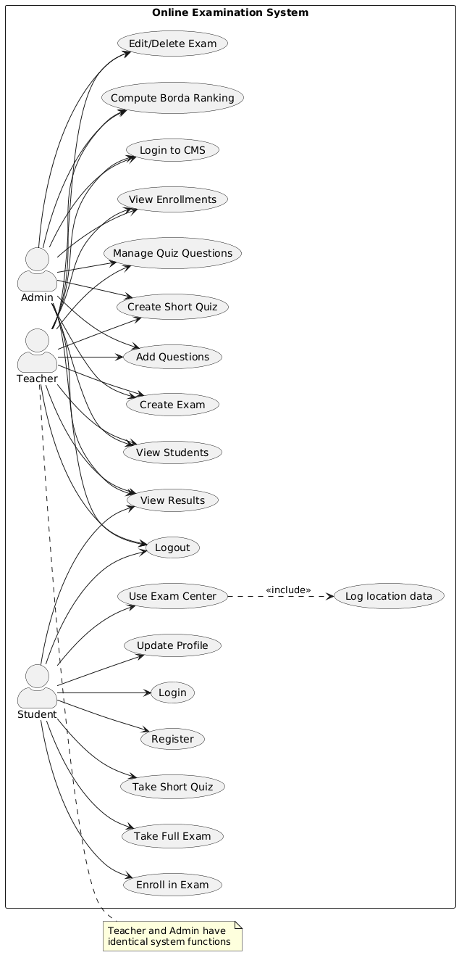
Figure 3.1: Use Case diagram of Online Examination System

Above use case diagram summarizes the detail of system and the users within the Online Examination system. We can see the events and flow of events in above diagram. Above diagram summarizes how users will be interacting with the system with different events. Other events can be triggered anonymously too. Admin can do special event of managing overall system.
Non –functional requirements
Non-functional requirements make the functioning of the system easier and effective. The non–functional requirements of this project are:
  - Security: Software security is an idea implemented to protect software against malicious attacks and other hacker risks so that the software continues to function correctly under such potential risks. Security is necessary to provide integrity, authentication, and availability.
  - Reliability: Reliability is defined as the probability of failure-free software operation for a specified period in a specified environment. Software Reliability is hard to achieve because the complexity of software tends to be high.
  - Performance: Performance is an indicator of how well a software system or component meets its requirements for timeliness. Timeliness is measured in terms of response time or throughput. The response time is the time required to respond to a request.
  - Maintainability: The ease with which a software system or component can be modified to correct faults, improve performance or other attributes, or adapt to a changed environment is known as maintainability.
  - Usability: Usability refers to the quality of a user's experience when interacting with products or systems, including websites, software, devices, or applications. Usability is about effectiveness, efficiency, and the overall satisfaction of the user.
  - Delivery in time: Software delivery is the process of deploying an application to the market. The software should be completed within the allotted time and delivered on time.
3.1.2 Feasibility Analysis
The feasibility study concluded that the project is able to be implemented successfully as it was carefully planned.
- Technical Feasibility Study
The technical feasibility assessment focused on the system's compatibility with existing technologies and infrastructure. The study confirmed that the PHP and JS stack stack was well-suited for the project, ensuring seamless integration and scalability.
- Operational Feasibility Study
This project aligned seamlessly with existing library processes and workflows. User- friendly interfaces for both administrators and users ensured smooth adoption and integration into day-to-day operations. Due to simplicity of project training requirements were minimal, further enhancing operational feasibility.
- Economic Feasibility Study
This OES project is an academic project so that most of the software’s would be manageable. We only be needing a laptop and a working internet connection to run the application. As a result, no economic feasibility assessment is required.
d. Schedule Feasibility:
The project was finished on schedule and without any delays, guaranteeing that it is prepared for usage as intended.

Table 3.1: Gantt table for Online Examination system
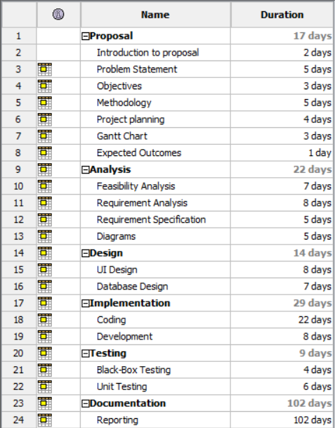

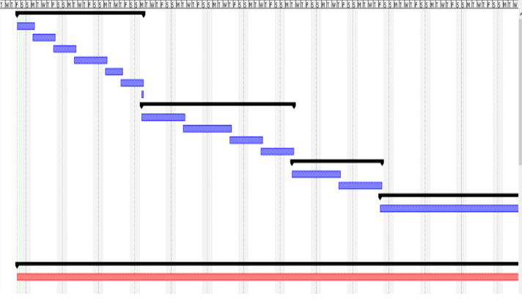
Figure 3.2: Gantt Chart for Online Examination System

3.1.3 Object Modelling using Class and Object Diagrams
To create object and class diagrams, it was needed to identify the main objects and their relationships in the context of the chat application. Based on the features described earlier,
here's a description of the main objects and their relationships.

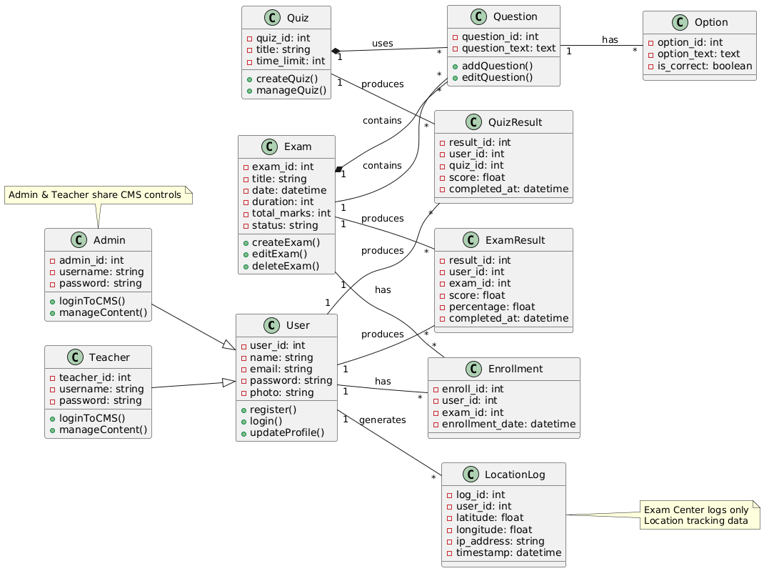
Figure 3.3: Class Diagram for Online Examination System
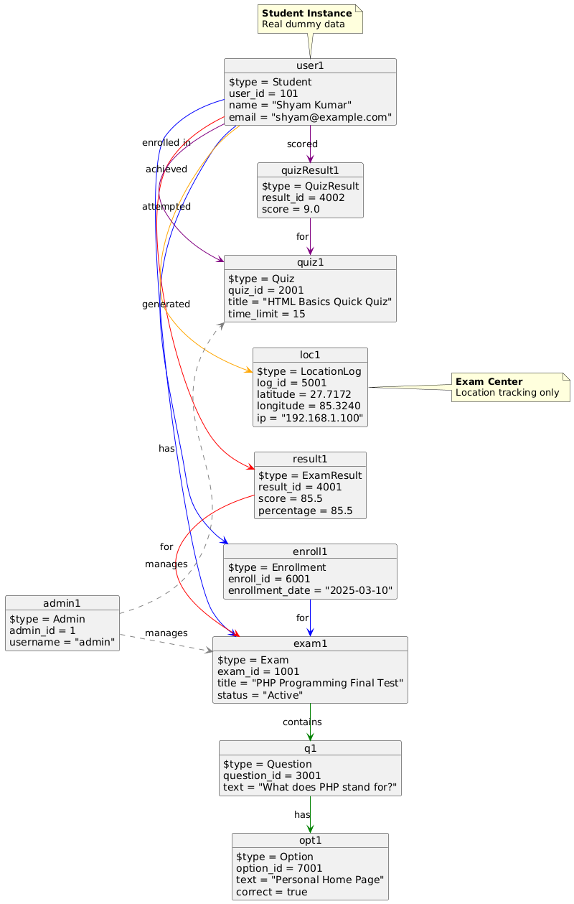
Figure 3.4: Object Diagram of Online Examination System

3.1.4 Dynamic Modelling using Sequence Diagram
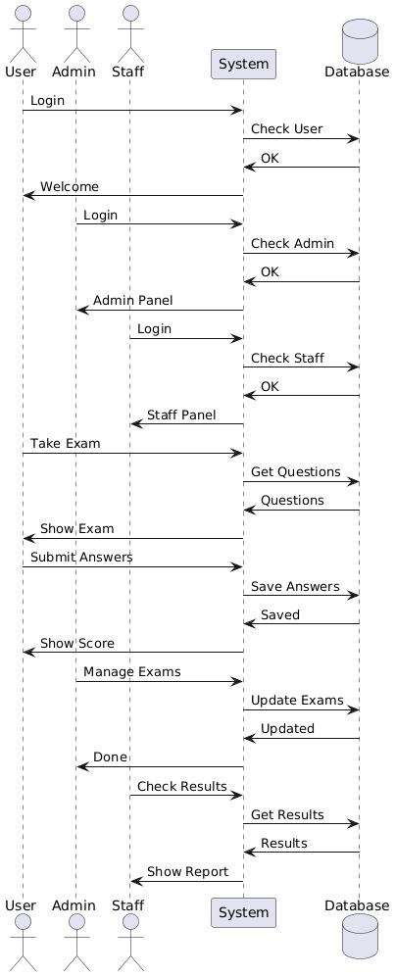
Figure 3.5: Sequence diagram for Online Examination System
3.1.5 Process Modeling using Activity Diagram
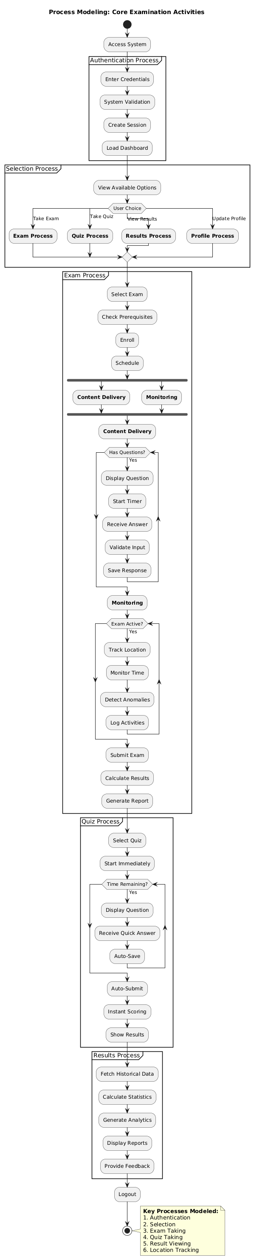
Figure 3.1.5 Process Modeling using Activity Diagram
3.6: Admin Activity Diagram for Online Examination system
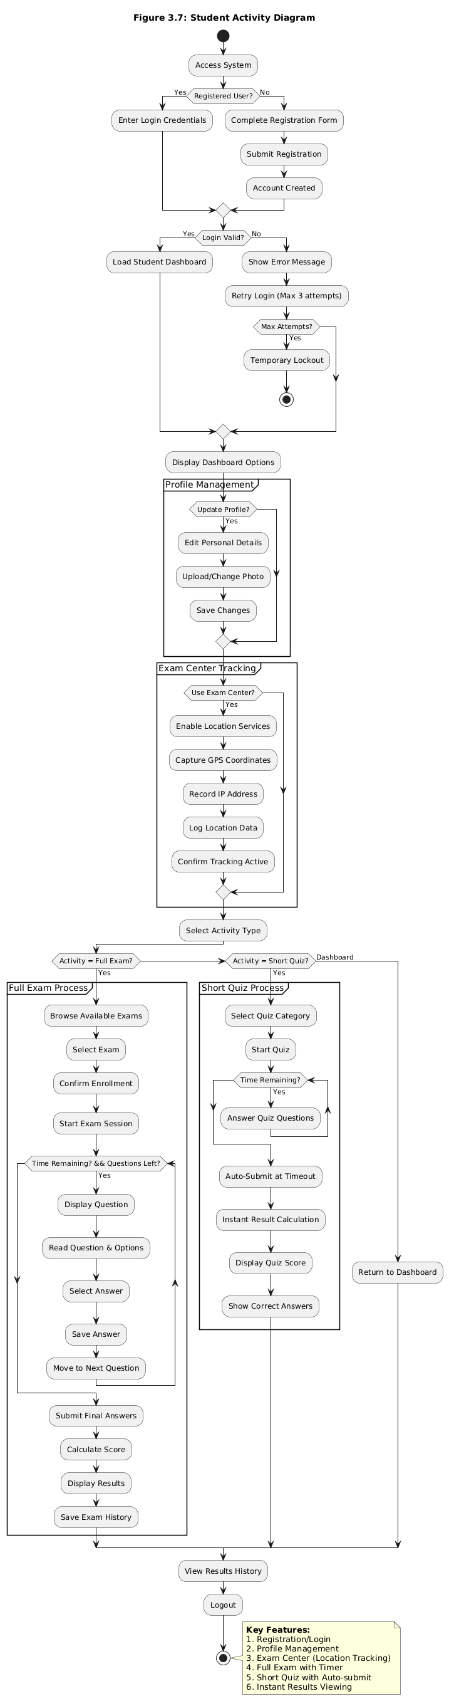
Figure 3.6: Admin Activity Diagram for Online Examination System
The activity diagram illustrates the workflow of an admin managing the system. It begins with the admin logging in, where their credentials are validated. Upon successful validation, the admin can access various management modules. These modules include actions like creating, viewing, updating, and deleting records, depending on the specific functionality of each module. After completing the required operations, the workflow concludes. This diagram effectively highlights the admin's key responsibilities and the sequential flow of activities within the system.
Implementation Details of Modules (Description of procedures/functions)
This section elaborates on how the modules are implemented and what functions does they contribute to the system.
1. Admin Module: This module manages administrator accounts. It stores admin email, password, verification code, admin type (master or sub-master), account creation date, and email verification status. Administrators can log in to the system to create exams, manage questions, and control system operations.
2. User Module: This module handles all registered users. It stores user information such as name, email address, password, gender, address, mobile number, profile image, verification code, and email verification status. This module is used for user authentication and authorization.
3. Online Exam Module: This module stores details of all exams created by the admin. It includes the exam title, date and time, duration, total number of questions, marks for correct and wrong answers, exam status, and unique exam code. It controls the scheduling and availability of exams.
4. Question Module: This module manages all questions related to exams. Each question is linked to a specific exam and includes the question text and the correct answer option. It allows admins to create, update, and delete exam questions.
5. Option Module: This module stores the multiple-choice options for each question. It includes the option number and option text and is used to display answer choices to users during the exam.
6. User Exam Enrollment Module: This module records which users are enrolled in which exams. It stores the user ID, exam ID, and attendance status (Present or Absent). This module controls user participation and tracks attendance.
7. User Answer Module: This module stores the answers submitted by users during the exam. It records the selected option and marks obtained for each question. This module is used to calculate total marks and generate results.

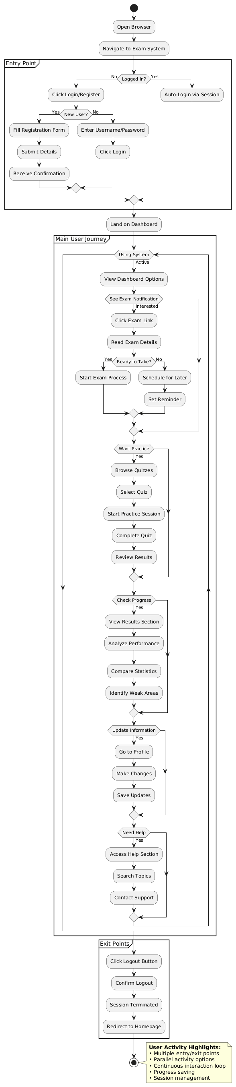
Figure 3.7: User Activity Diagram for Online Examination System
The activity diagram for user actions represents the workflow of a user interacting with the system. It begins with the user accessing their account, allowing them to manage their profile and book-related activities. In the User Profile module, users can perform actions such as creating, viewing, and updating their profiles. Similarly, in the Book Request module, users can view their existing book requests and update them as needed. This diagram clearly outlines the streamlined flow of user operations within the system, ensuring efficient management of user-specific functionalities.

3.2 System Design
To represent all the requirements of the system in graphical form, different diagram designs are carried out of the system, and they are as follow:

3.2.1 Refinement of Class diagram
It involves adding additional information such as access modifiers of the fields and methods along with clarifying the relationship between classes. It is the elaborate process of the initial representation to provide a more comprehensive view of the system.

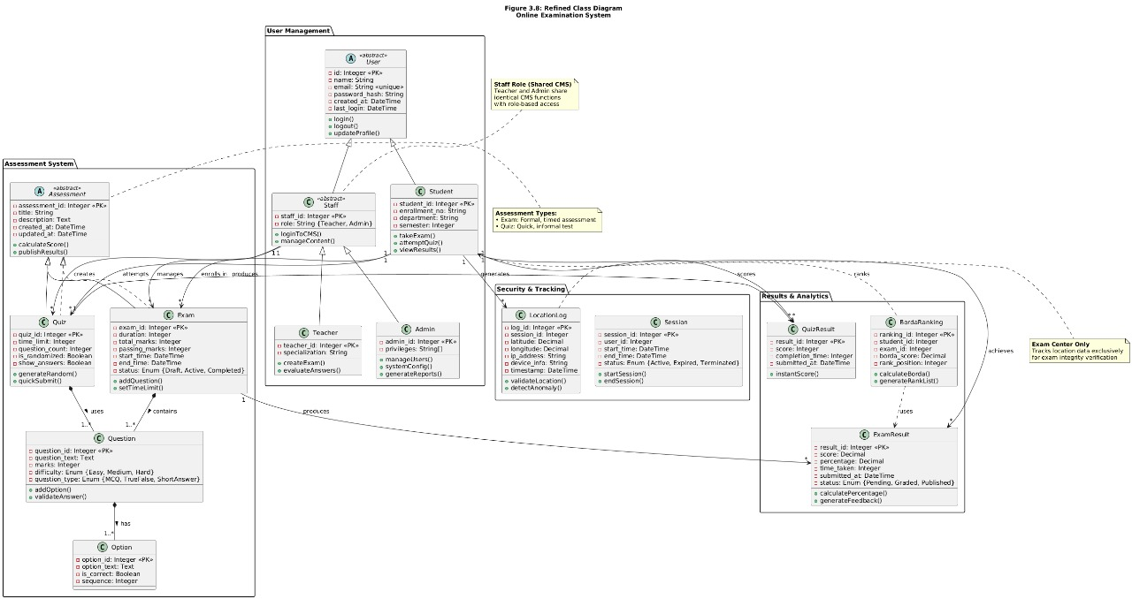
Figure 3.8: Refinement of Class Diagram for Online Examination System

3.2.2 Component Diagrams

Figure 3.9: Component Diagram for Online Examination System

3.2.3 Deployment Diagram
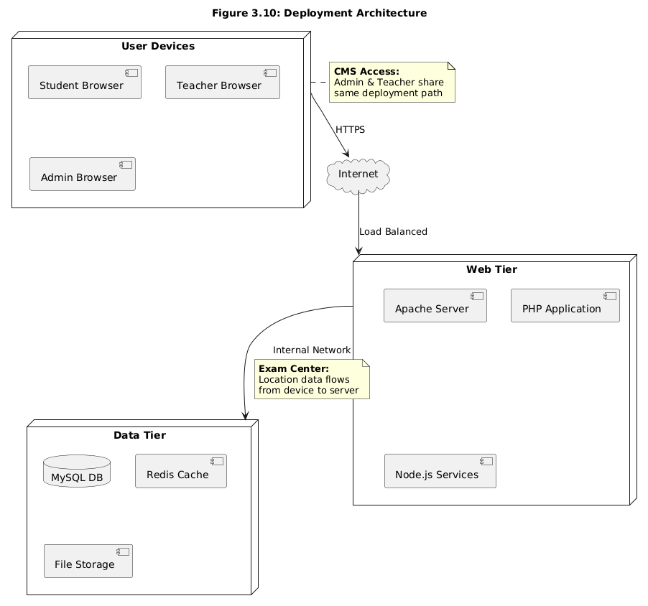
Figure 3.10: Deployment Diagram for Online Examination System

3.3 Algorithm for Online Examination System:
The system incorporates two major algorithms to enhance fair evaluation of students and accurate distance calculation for exam center navigation.

3.3.1 Boundary Value Ranking Algorithm
The system uses a Boundary Value Algorithm to categorize students based on their exam performance. This algorithm works by generating cutoff values (boundaries) that divide student scores into groups such as Top 10%, Top 25%, Top 50%, Bottom 25%, and Bottom 10%. To ensure fair and accurate classification, the system combines three approaches: the Simple Percentile Rule, which uses fixed thresholds; the Standard Deviation Method, which calculates dynamic boundaries using statistical measures; and the Quartile Method, which provides rank-based cutoffs. Together, these methods create a reliable boundary value model for evaluating student performance.
Formula Section
1. Simple Percentile Rule (Fixed Boundaries)
[Top\ 10% = 90]
[Top\ 25% = 75]
[Top\ 50% = 50]
[Bottom\ 25% = 25]
[Bottom\ 10% = 10]

2. Standard Deviation Based Boundaries
(\mu) = Mean score
(\sigma) = Standard deviation
[Excellent = \mu + 1.5\sigma]
[Very\ Good = \mu + \sigma]
[Good = \mu]
[Average = \mu - \sigma]
[Needs\ Improvement = \mu - 1.5\sigma]

3. Quartile-Based Boundaries (Simplified)
[Q1\ (Top\ 25%) = 75]
[Q2\ (Median\ Top\ 50%) = 50]
[Q3\ (Bottom\ 25%) = 25]

3.3.2. Haversine Distance Formula
The Haversine Formula is used to calculate the straight-line geographical distance between two points on Earth using their GPS coordinates (latitude and longitude). In the Online Examination System, this algorithm determines the distance between a student's current location and the designated examination center.
The calculated distance is further utilized for estimating travel time and expected arrival schedules, improving logistical planning for students attending physical examination venues.
Why Used
- Provides highly accurate positioning-based distance calculations without depending on external APIs.
- Operates in constant time (O(1)), ensuring fast response.
- Serves as a fallback method when online routing APIs are unavailable.
- Ideal for real-time distance measurement applications.
Mathematical Formulation
Let:
Start coordinates = (φ₁, λ₁)
End coordinates = (φ₂, λ₂
Earth’s radius = R = 6371 km
[a = \sin^2\Bigl(\frac{Δφ}{2}\Bigr)\cos(φ_1)\cos(φ_2)\sin^2\Bigl(\frac{Δλ}{2}\Bigr)]
[c = 2 \cdot \text{atan2}(\sqrt{a}, \sqrt{1 - a})]
[d = R \cdot c]
Where:
( Δφ = φ_2 - φ_1 )
( Δλ = λ_2 - λ_1 )
System Implementation
Retrieve:
- Student GPS coordinates
- Exam center GPS coordinates.
- Convert latitude and longitude from degrees to radians.
Apply the Haversine formula:
function calculateDistance($lat1,$lon1,$lat2,$lon2){
$R = 6371;
$dLat = deg2rad($lat2 - $lat1);
$dLon = deg2rad($lon2 - $lon1);
$a = sin($dLat/2)**2 +
cos(deg2rad($lat1))*cos(deg2rad($lat2))*
sin($dLon/2)**2;
$c = 2 * atan2(sqrt($a), sqrt(1-$a));
return round($R * $c, 2);
}
Display calculated distance in kilometers on the user dashboard and apply speed-based logic to estimate travel time.

CHAPTER 4
IMPLEMENTATION AND TESTING

4.1. Implementation
This describes how the system works and how it can be important for Online Examination. So, at first, we did research about the necessary tools and sources required to be developed. Many tools and technologies that were utilized to develop the system are discussed in the proceeding chapter.
4.1.1. Tools Used (CASE tools, Programming language, Database platforms)
The various system tools that have been used in developing both the front end and backend of the project are being discussed in this chapter. The project utilizes JavaScript as the primary programming language. The CASE tools used for a project are based on the requirements of the project. Following types of CASE tools are used for this project:
- IDEs (Integrated Development Environments): Visual Studio Code, a lightweight and versatile code editor commonly used for JavaScript-based development.
- Version Control: Git was essential for maintaining version history, controlling code modifications, and guaranteeing the integrity of the development process. It offered a dependable means of monitoring development, planning modifications, and reverting to earlier iterations when required.
- Diagramming Tools: Chatgpt, Draw.io and DbDiagram.io is used for creating database schema design, entity-relationship diagrams, and other visual representations of system architecture.
Table 4.1: Tools Used for Online Examination system
Tools | Purpose
HTML, CSS, JS | Frontend Development
PHP | Back-end Development
XAMP | PHP Runtime
My Sql | Database
VS Code IDE | Coding and Development
Figma | Designing wire-frame and UI
GitHub | Version Control

Frontend Development (HTML, CSS, JavaScript):
HTML is used for structuring web pages, CSS is used for styling and layout, and JavaScript is used to add interactivity and dynamic behavior to the user interface.
Back-end Development (PHP):
PHP is a server-side scripting language used to handle business logic, process user requests, manage sessions, and interact with the database to create a dynamic web application.
XAMPP (PHP Runtime):
XAMPP is a local development environment that includes Apache server, PHP interpreter, and MySQL database, enabling developers to run and test PHP applications on a local machine.
MySQL (Database):
MySQL is a relational database management system used to store, retrieve, and manage application data such as user details, exam questions, and results.
VS Code IDE (Coding and Development):
Visual Studio Code is a powerful and lightweight code editor that offers smart code completion, debugging tools, and extensions to improve development speed and efficiency.
Figma (Designing Wire-frame and UI):
Figma is a cloud-based design tool used to create wire-frames, prototypes, and user interface designs to improve the visual layout and user experience.
GitHub (Version Control):
GitHub is a web-based platform used for source code management. It helps track changes, maintain code versions, and enables collaboration among developers.

4.1.2. Implementation Details of Modules (Description of procedures/functions)
This section elaborates on how the modules are implemented and what functions does they contribute to the system.
1. Admin Module : This module manages administrator accounts. It stores admin email, password, verification code, admin type (master or sub-master), account creation date, and email verification status. Administrators can log in to the system to create exams, manage questions, and control system operations.
2. User Module : This module handles all registered users. It stores user information such as name, email address, password, gender, address, mobile number, profile image, verification code, and email verification status. This module is used for user authentication and authorization.
3. Online Exam Module: This module stores details of all exams created by the admin. It includes the exam title, date and time, duration, total number of questions, marks for correct and wrong answers, exam status, and unique exam code. It controls the scheduling and availability of exams.
4. Question Module: This module manages all questions related to exams. Each question is linked to a specific exam and includes the question text and the correct answer option. It allows admins to create, update, and delete exam questions.
5. Option Module: This module stores the multiple-choice options for each question. It includes the option number and option text and is used to display answer choices to users during the exam.
6. User Exam Enrollment Module: This module records which users are enrolled in which exams. It stores the user ID, exam ID, and attendance status (Present or Absent). This module controls user participation and tracks attendance.
7. User Answer Module: This module stores the answers submitted by users during the exam. It records the selected option and marks obtained for each question. This module is used to calculate total marks and generate results.

4.2. Testing
Based on the software requirement specification document, testing was performed to investigate and validate the behavior of a fully integrated software product. Before deploying an application or website, it must be thoroughly tested. As a result, this application was tested. Some of the types of testing that we did are described below.
4.2.1. Test Cases for Unit Testing
A unit test is a way of testing a unit - the smallest piece of code that can be logically isolated in a system. In most programming languages, that is a function, a subroutine, a method or property.

Registration test case
Table 4.2: Registration test case for Online Examination system
ID | Test Case Description | Test Data | Expected Output | Actual Output | Result
1 | User forgets to input first name and last name field. | First name =  Last name = | Display error message ‘First name and Last name is required’ and prevent form submit. | As expected | Pass
2 | User forgets to input E-mail field. | Email = | Display error message ‘E-mail is required’ and prevent form submit. | As expected | Pass
3 | User inputs duplicate E-mail | Email = rajesh@gmail.com | Display error message ‘Request Failed’ and prevent form submit. | As expected | Pass
4 | User forgets to input Phone number field. | Phone number = | Display error message ‘Phone number is required’ and prevent form submit. | As expected | Pass
5 | User inputs different password and confirm password value | Password = Aa12345#  Confirm password = 12345678 | Display password and confirm password doesn’t match. | As expected | Pass
6 | User inputs all the data as required | First name = Jay  Last name = Rai  Email= jay@gmail.com  Phone = 9841971529  Password = Ab@1  Confirm password = Ab@1 | Verify Email, OTP Code send to email | As expected | Pass

Login test case
Table 4.3: Login test case for Online Examination system
ID | Test Case Description | Test Data | Expected Output | Actual Output | Result
1 | User forgets to input email field. | E-mail= rohan@gmail.com  Password=rohan 123 | Display error message ‘Email is required’ and prevent form submit. | As expected | Pass
2 | User forgets to input password field. | E-mail =  Rocky@gmail.comPassword = rocky123 | Display error message ‘Password is required’ and prevent form submit. | As expected | Pass
3 | User provides invalid e-mail and password information. | E-mail = abc@gmail.com  Password = 1234567 | Display error message ‘E-mail or password is not correct. Please try again’ and prevent login. | As expected | Pass
4 | User provides valid information. | E-mail = rajesh@gmail.com  Password = 12345 | User is logged in and redirected to home screen. | As expected | Pass

Admin login
Table 4.4: Admin login test case for Online Examination system
ID | Test Case Description | Test Data | Expected Output | Actual Output | Result
1 | Input invalid Email or Password. | Username = admin@gmail.com  Password = 123456789 | Alert ‘Invalid details’ and prevent login. | As expected | Pass
2 | Input valid username and password | Username = adi@gmail.com  Password = 12345 | Login successfully and redirect to dashboard. | As expected | Pass

Test case for Creating Exams
Table 4.5: Exam Creation test case for Online Examination system
ID | Test Case Description | Test Data | Expected Output | Actual Output | Result
1 | Admin creates examination with input Title field. | Title = Math | Display exam created and other specification | As expected | Pass
2 | Admin add question to the exam. Specifying the marks and options | Question= what is full form of SQL. | Display question as created’ | As expected | Pass
3 | Admin input all validated data | All data inserted | Display message ‘New Book Created Successfully’ | As expected | Pass

Test case for Updating the exam
Table 4.6: Update book test case for Online Examination system
ID | Test Case Description | Test Data | Expected Output | Actual Output | Result
1 | Admin forgets to input Title. | Title = | Display error message ‘Title is required’ | As expected | Pass
2 | Admin forgets to input date and time. | Date And Time= | Display error message ‘ required Field’ | As expected | Pass
3 | Admin forgets to input Author. | Author= | Display error message ‘Author is required’ | As expected | Pass
4 | Admin forgets to input Description | Description = | Display error message ‘Description is required’ | As expected | Pass
5 | Admin forgets to upload image. | Image = | Display error message ‘Please select a file’ | As expected | Pass
6 | Admin input all validated data | All data inserted | Display message ‘Successfully edited’ | As expected | Pass

Test case for Searching Exam list
Table 4.7: Searching book test case for Online Examination system
ID | Test Case Description | Test Data | Expected Output | Actual Output | Result
1 | Title: Math | Search Success | Searched Exam | Search  exam | Pass

Test Case for Forgot Password
Table 4.8: Forgot password test case for Online Examination system
S.N. | Test Case Description | Test Data | Expected Output | Actual Output | Result
1 | Email: abc@gmail.com Phone: 12345 | Phone number must be 10 digits long and start from ‘9’ | Display Change Password Form | Invalid Email or Phone | Fail
2 | Email: amit@gmail.com Phone: 9847612345 | Credentials Validation Success | Display Change Password Form | Display Change Password Form | Pass

4.2.1. Test Cases for System Testing
System Testing plays a crucial role in ensuring that the entire system functions as intended and meets the specified requirements. System testing is done to check whether the software or product meets the specified requirements or not.
Table 4.9: System testing for Online Examination system
S.N. | Test Case Description | Test Data | Expected Output | Actual Output | Result
1 | User inputs all the data as required. | First name = John  Last name = Rai  Email = john@gmail.com  Phone = 9841971529  Password = Ab@1  Confirm password = Ab@1 | Verify Email, OTP Code sent to email. | As expected | Pass
2 | User provides valid information (Login). | E-mail = john@gmail.com  Password = Ab@1 | User is logged in and redirected to home screen of the system. | As expected | Pass
3 | Enroll and take exam on the assigned date. |  | Directs to the question Pages | Question pages appears. | Pass
4 | Email: amit@gmail.com  Phone: 9847612345 (Forgot Password) | Email = admin@gmail.com  Phone = 9847612345 | Credentials validation success, Display Change Password Form | Display Change Password Form | Pass
5 | User Obtains the Current location. |  | User Location tracking | As expected | Pass
6 | User obtains exam result. | Answer to the listed question. | Graphs and percentages. | As expected | Pass

4.3 Result Analysis
A. Borda Count Ranking Algorithm
The Borda Count Ranking Algorithm is applied to generate final student rankings by combining exam performance (percentage scores) with attendance records. Unlike traditional grading methods that rank students only by marks, this algorithm provides a multi-criteria evaluation that ensures fairness and balanced judgement. The ranking results displayed to administrators reflect both academic achievement and exam participation, preventing biased grading outcomes.
Input Data
The ranking process operates on the following data inputs:
• Student Exam Scores
Total marks obtained by each student
Maximum possible marks for each exam
• Attendance Status
Present / Absent data from the exam enrollment table
• Student Identifiers
User ID and exam ID mappings
Process Breakdown
1. Data Extraction
• Retrieve all student answer records from the user_exam_question_answer table.
• Calculate individual total marks using sum aggregation.
• Fetch attendance status from the user_exam_enroll_table.
• Compute exam percentages using:
[\text{Percentage} = \frac{\text{Total Marks}}{\text{Total Possible Marks}} \times 100]
2. Independent Ranking Creation
• Ranking List 1 – Students sorted by descending percentage.
• Ranking List 2 – Students sorted by attendance status (Present given higher priority).
3. Borda Point Assignment
For each ranking list containing N students:
Points = N - Rank + 1
Each student receives two point values:
• Points from academic ranking
• Points from attendance ranking
4. Final Rank Generation
• The system sums the two point values for each student:
[\text{Final Score} = \text{Performance Points} + \text{Attendance Points}]
• Students are sorted by Final Score (highest first).
• This produces the final exam ranking list shown on the admin dashboard.
Mathematical Formulation
Let:
• ( r_1 ) = Rank based on exam percentage
• ( r_2 ) = Rank based on attendance
• ( N ) = Total number of students

Borda Point Function:
[
P(x) = N - x + 1
]
Total Score:
[
S = P(r_1) + P(r_2)
]
Final ranking is determined by ordering students according to descending S values.
Example Output
For an exam with 4 students:
Student | Percentage Rank | % Points | Attendance Rank | Att. Points | Borda Score
A | 1 | 4 | 1 | 4 | 8
B | 2 | 3 | 2 | 3 | 6
C | 3 | 2 | 4 | 1 | 3
D | 4 | 1 | 3 | 2 | 3
Final ranking output:
A → Rank 1
B → Rank 2
D → Rank 3
C → Rank 4
Results Interpretation
• Balanced Evaluation: Students are fairly ranked based on both performance and participation.
• Tie Handling: When two students receive equal marks, attendance ranking contributes to natural separation.
• Transparency: The ranking process is deterministic, reproducible, and verifiable.
• Scalability: The model handles large candidate sets efficiently without performance degradation.
B.Haversine Distance Formula
The Haversine Distance Formula computes the geographical distance between a student’s current location and the assigned examination center. The formula uses latitude and longitude data obtained via GPS to determine the straight-line distance over the Earth's curvature. The resulting distance measurement is displayed to the student and is further applied in travel-time estimation functions.
Input Data
The algorithm processes the following inputs:
• Student GPS coordinates (latitude, longitude)
• Exam center GPS coordinates (latitude, longitude)
• Earth’s radius constant (R = 6371 km)
Process Breakdown
1. Coordinate Acquisition
• Student coordinates are captured via browser geolocation services.
• Exam center coordinates are retrieved from the database.
2. Distance Calculation
• All latitude and longitude values are converted into radians.
The Haversine function is applied to compute distance:
[a = \sin^2(\frac{Δφ}{2}) + \cos(φ_1)\cos(φ_2)\sin^2(\frac{Δλ}{2})]
[c = 2 \cdot \text{atan2}(\sqrt{a}, \sqrt{1-a})]
[d = R \cdot c]
3. Output Generation
• Distance is rounded to two decimals and displayed in kilometers.
• Speed-based models are then used to estimate travel time and expected arrival time.
Mathematical Formulation
• Start location = ( (φ_1, λ_1) )
• Destination = ( (φ_2, λ_2) )
• Earth radius ( R = 6371 )
Final distance:
[D = R \cdot 2 \cdot \text{atan2}
\left(\sqrt{a},\sqrt{1-a}\right)]
Example Output
{ "userLocation": "27.7011, 85.3204",
"examCenter": "27.7172, 85.3240",
"distance_km": 2.13,
"estimatedTravelTime": "9 minutes"}
Results Interpretation
• Accuracy: Generates high-precision real-world distance values.
• Reliability: Provides consistent output without external API dependency.
• Usability: Enables students to accurately plan their travel schedules.
• Performance: Runs in constant time with negligible computational cost.

CHAPTER 5
CONCLUSION AND FUTURE RECOMMENDATIONS

5.1 Lesson Learnt / Outcome
Developing the Online Examination System (OES) provided extensive learning opportunities across technical, analytical, and managerial domains. Throughout the project, multiple challenges were encountered—such as handling authentication, structuring exam modules, managing relational data, and ensuring system security. Overcoming these challenges helped strengthen both technical competencies and professional skills.
Problem Solving Skills:Building the OES required addressing several technical issues, including secure user authentication, preventing cheating, managing large question banks, and optimizing exam execution processes. Tackling these challenges enhanced our logical thinking, debugging ability, and system optimization skills. This experience also contributed to our understanding of real-world system complexity and scalability.
Writing Skills: Clear documentation was essential to describe system requirements, design models, test results, and project progress. Preparing structured reports improved our technical writing skills and our ability to communicate complex ideas in a concise and understandable manner.
Time management: Prioritizing tasks according to their impact and complexity was necessary to oversee several project phases, from feature development to testing. Effective time management helped us successfully achieve all important milestones and guaranteed the OES was delivered on schedule.
Independence and Self-Reliance: Developing the OES required a self-directed method of problem-solving, including database query optimization and algorithm debugging. While highlighting the value of cooperation and teamwork, this independence also encouraged self-assurance and ingenuity.
Project management: Managing a complex system development lifecycle was made easier with the help of the OES project. In order to ensure a methodical and efficient approach, we learned to break the project down into several phases, including requirement collecting, system design, implementation, testing, and deployment.
As OES was developed, developing important soft skills like time management and effective communication, enhanced collaborative processes, and acquired substantial technical expertise. In addition to producing a useful and intuitive recommendation system, this project was a thorough learning opportunity that equipped us for problems in the future.

5.2 Conclusion
The Online Examination System was successfully developed to provide a secure, efficient, and user-friendly platform for conducting exams digitally. The system automates key examination processes including user registration, question management, exam scheduling, evaluation, and result generation. It eliminates manual workload, reduces administrative errors, and improves the overall examination experience for both instructors and students.
The system integrates essential technologies—PHP/Node.js, MySQL, HTML/CSS/JavaScript, and secure authentication mechanisms—to ensure smooth performance and data integrity. The final implementation demonstrates reliability, scalability, and usability, fulfilling the core objectives of digital exam management.
Overall, the Online Examination System proves to be a practical solution for educational institutions seeking to modernize assessment processes. However, through real-world use and observation, several improvement areas have been identified that can further enhance its capabilities.

5.3 Future Recommendations
Although the system functions effectively, there are several advanced features that can be added in future to improve its usability, security, and scalability. Some recommended enhancements include:
1. AI-Based Question Recommendation & Difficulty Adjustment
Implement intelligent mechanisms that automatically recommend questions based on difficulty level, previous exam patterns, and student performance.
2. Automated Proctoring System
Add real-time monitoring features such as webcam tracking, face recognition, and suspicious activity alerts to minimize cheating.
3. Bulk Question Upload
Enable instructors to upload thousands of questions at once using CSV or Excel files to save time.
4. Advanced Result Analytics Dashboard
Provide visual analytics such as performance comparison, weak-area detection, time-per-question analysis, and predictive insight.

REFERENCES
[I] MoodleDocs, “Quiz module — Moodle Documentation,” https://docs.moodle.org/, Accessed: Dec. 2, 2025.
[II] OpenOLAT Documentation, “Assessments & IMS QTI Support,” https://docs.openolat.org/, Accessed: Dec. 2, 2025.
[III] TCExam Project, “TCExam Documentation & Features,” https://tcexam.org/, Accessed: Dec. 2, 2025.
[IV] Respondus, “LockDown Browser & Respondus Monitor Overview,” https://web.respondus.com/, Accessed: Dec. 2, 2025.
[V] ClassMarker, “Online Testing Platform Features,” https://www.classmarker.com/, Accessed: Dec. 2, 2025.
[VI] ProProfs, “ProProfs Quiz Maker — Features,” https://www.proprofs.com/quiz-school/, Accessed: Dec. 2, 2025.
[VII] Google, “Google Forms — Create Quizzes with Auto-Grading,” https://forms.google.com/, Accessed: Dec. 2, 2025.
[VIII] Questionmark, “Questionmark OnDemand Assessment Platform,” https://www.questionmark.com/, Accessed: Dec. 2, 2025.
[IX] ExamSoft, “ExamSoft Assessment Platform Overview,” https://examsoft.com/, Accessed: Dec. 2, 2025.

APPENDIX: SYSTEM SCREENSHOTS
Home Page
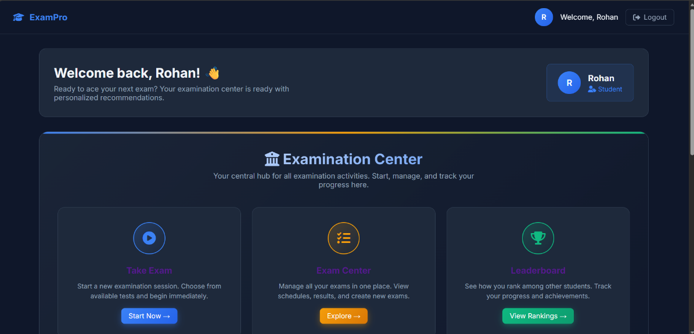

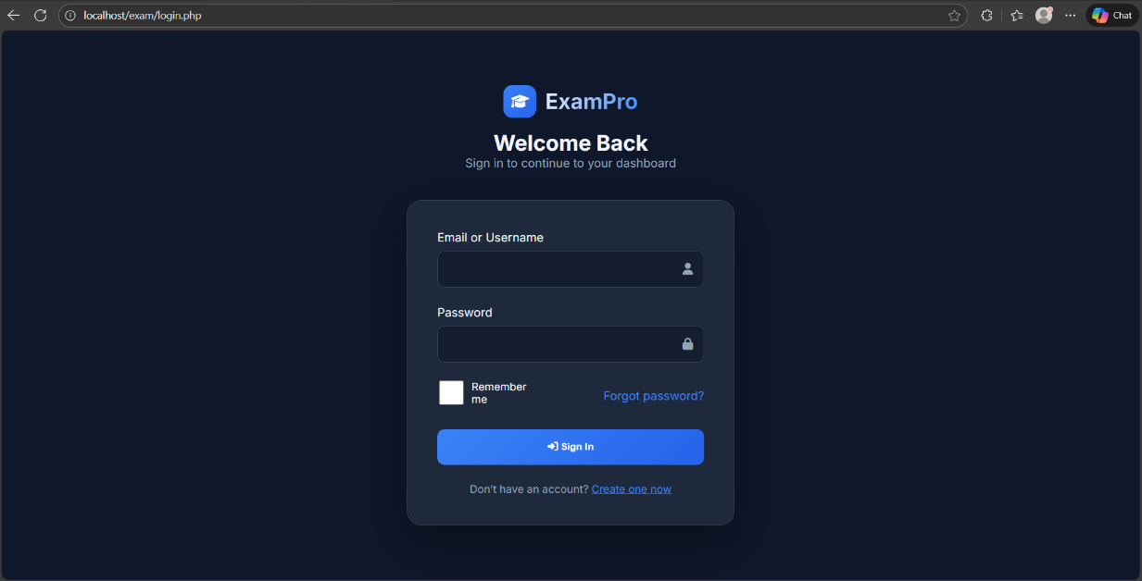
Login Page

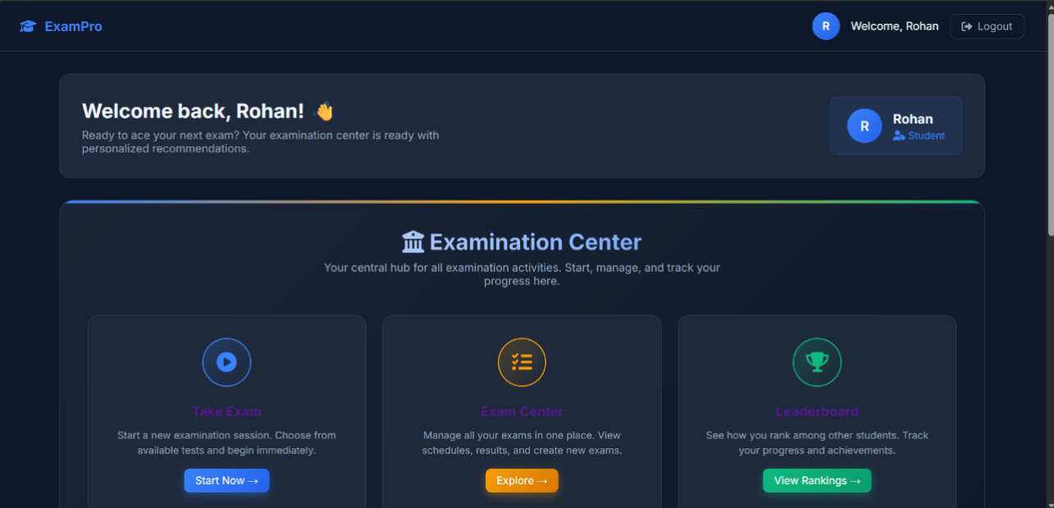
User dashboard

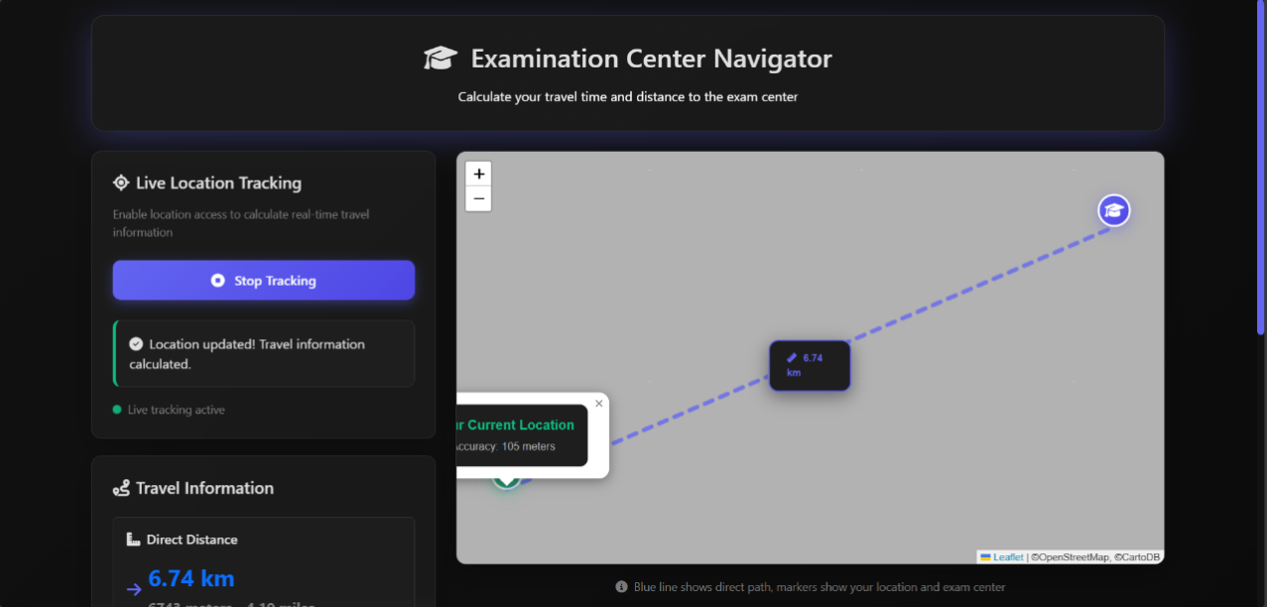

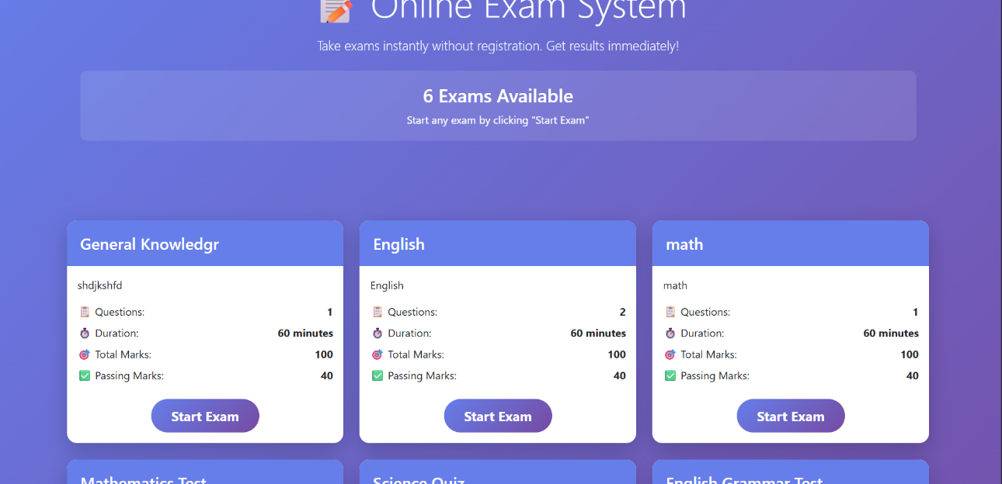

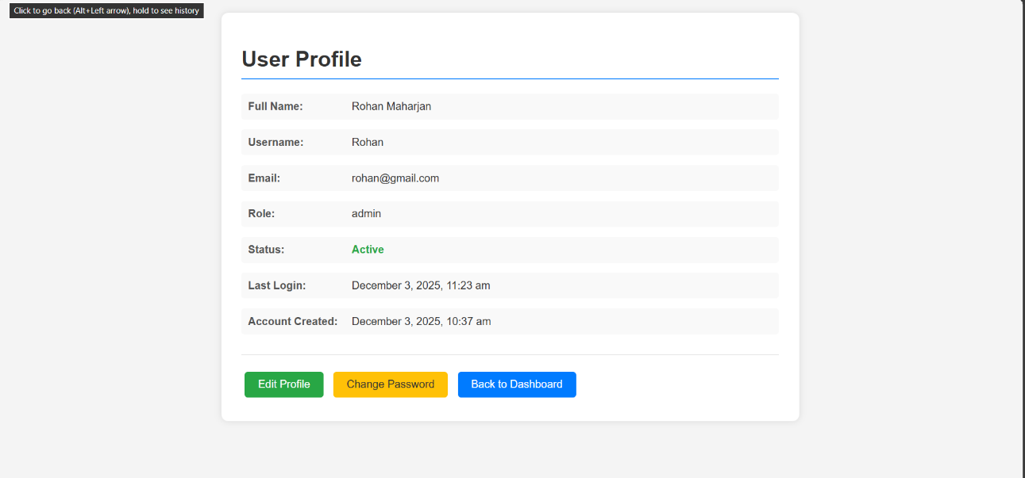

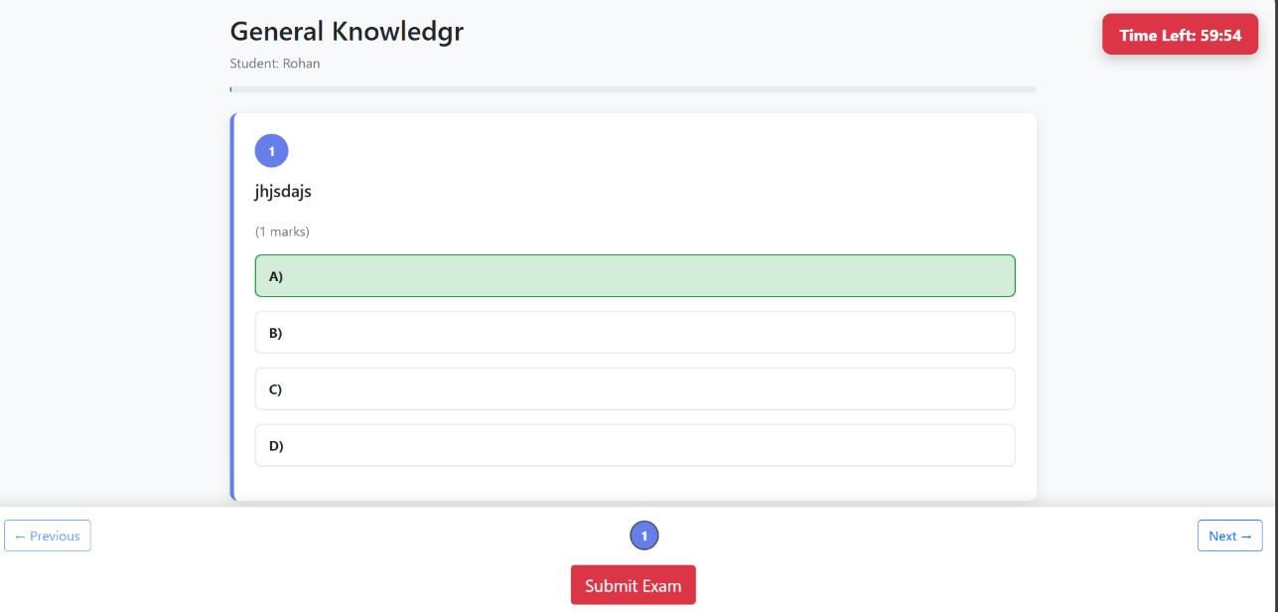

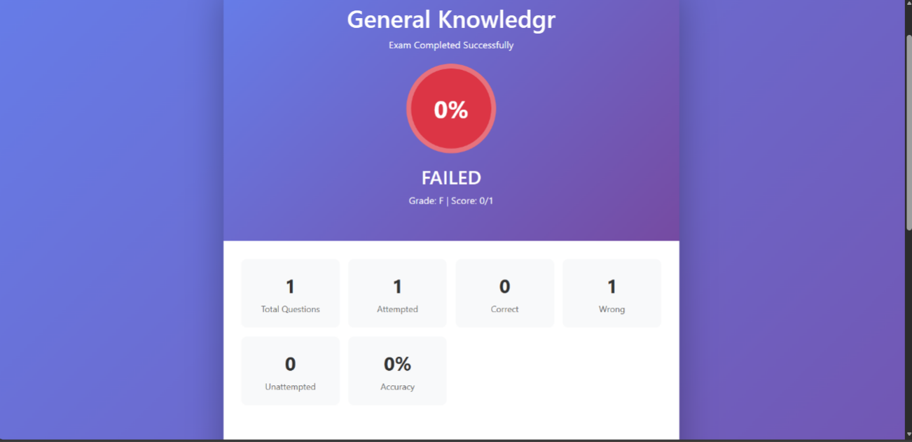

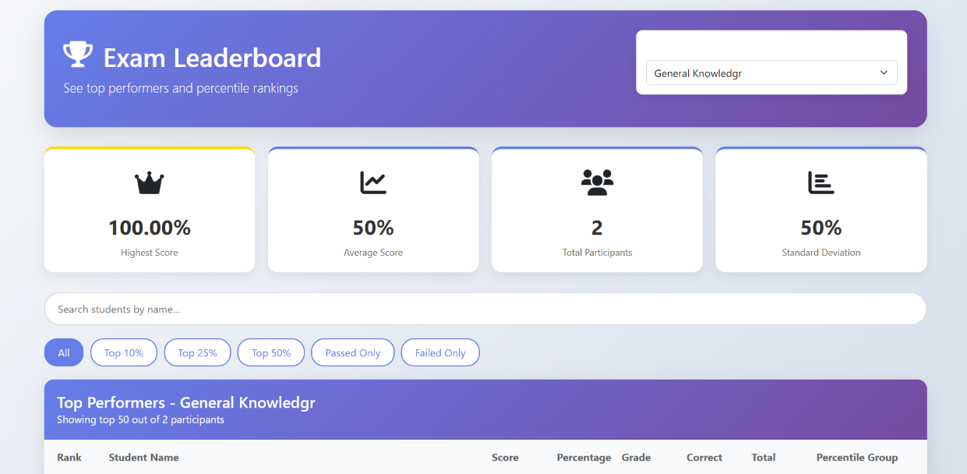

Admin Dashboard
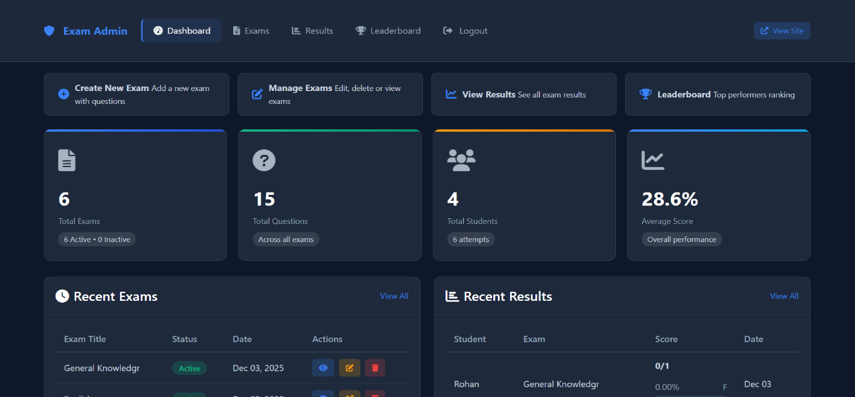

Login Page
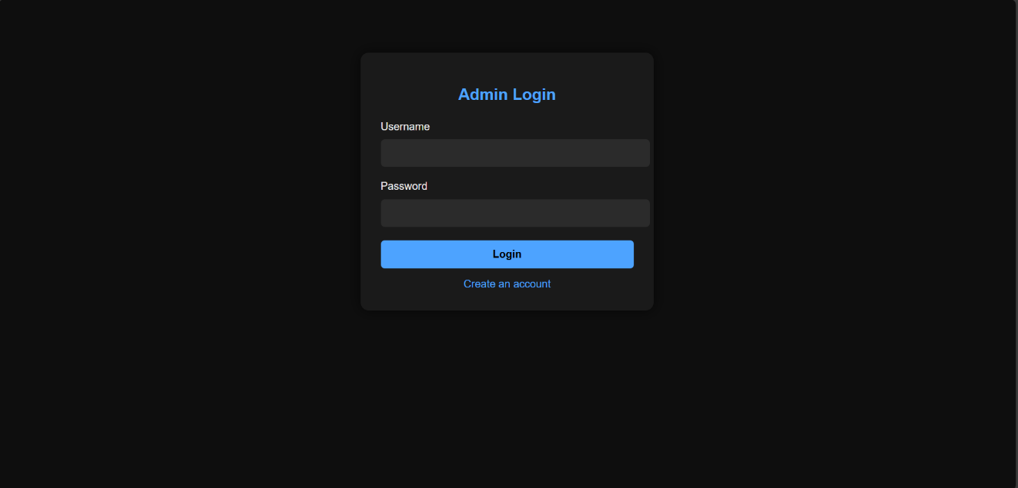

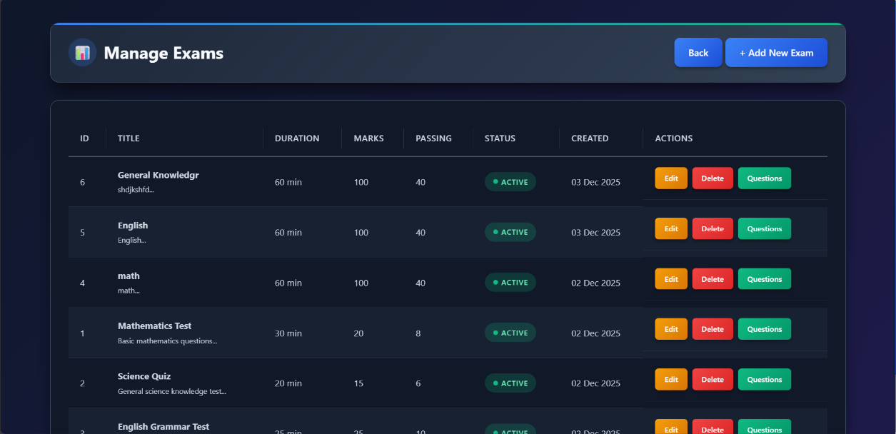

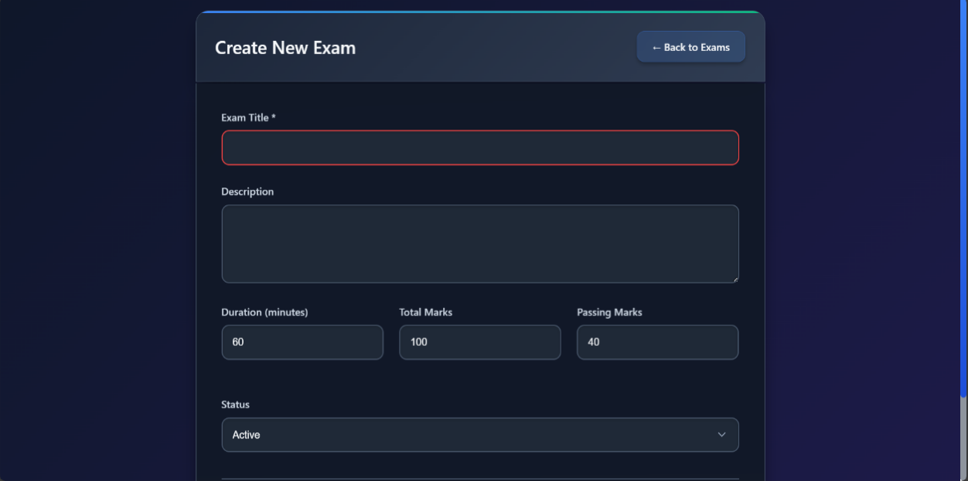

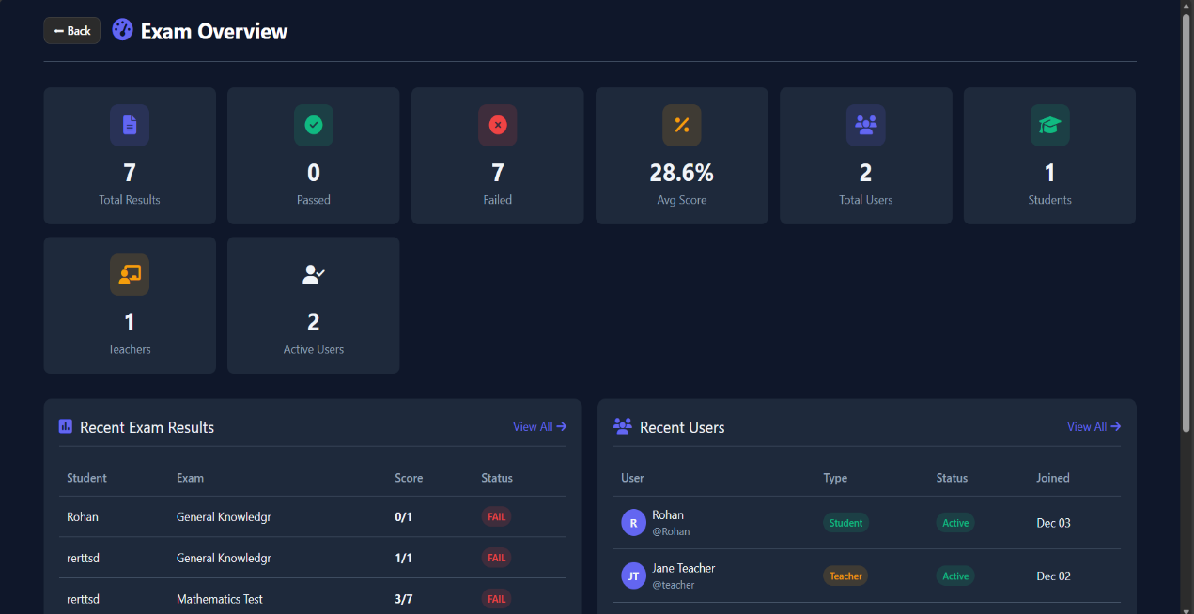

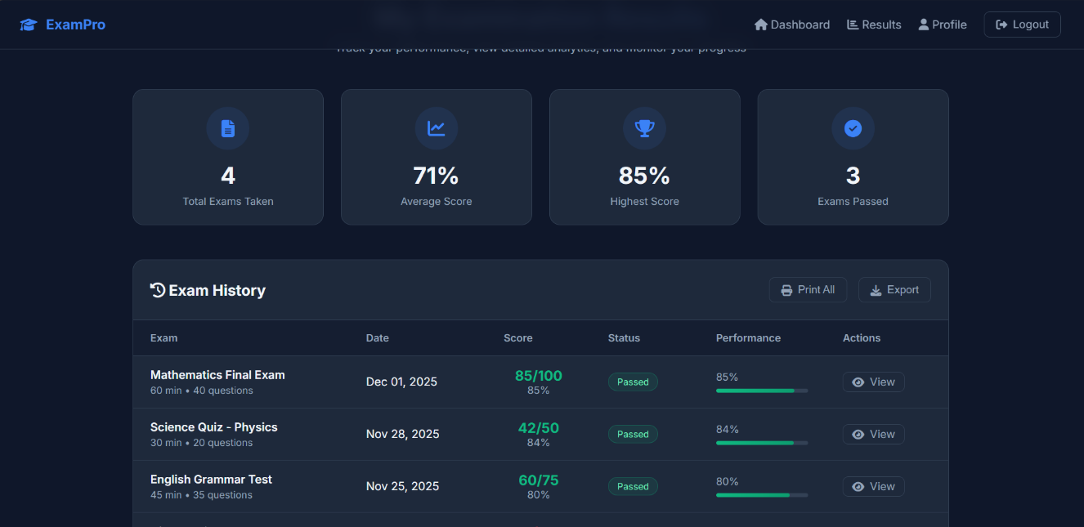
Everest Innovative College
Solteemode, Kathmandu
Bachelor in Computer Applications (BCA)
Project Log – Sheet
Year/Semester: 8th Sem
Project Name: Online Examination system
Supervisor’s Name: Bhesh Chaudhary
Student’s Name: Rohan Maharjan
S.N. | Date | Topic/Issue Discussed | Comments/Next Target | Signature of Supervisor

